Exercise 1: Configuring a Basic Spring Application
Set Up a Spring Project:
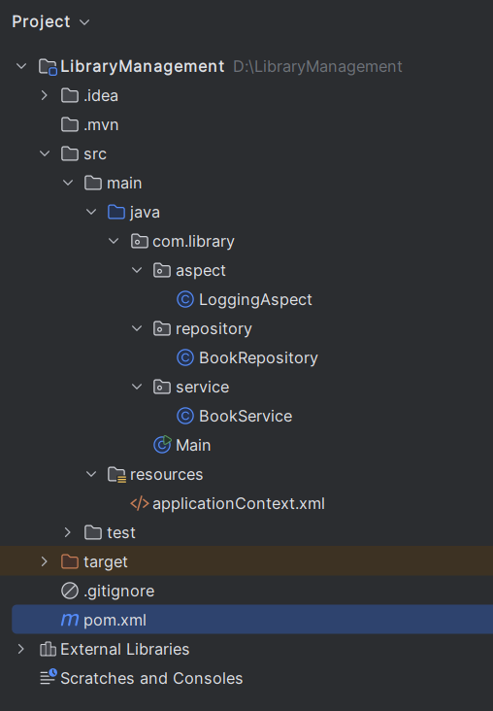

Add Spring Core dependencies in the pom.xml file
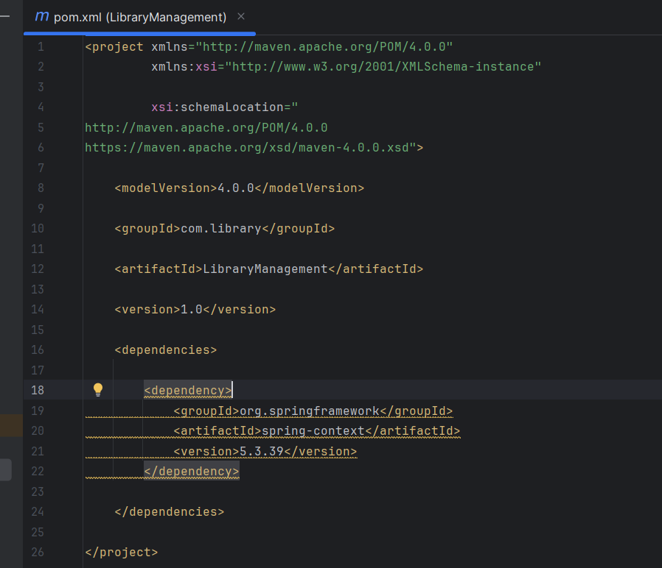

Create an XML configuration file named applicationContext.xml in the src/main/resources directory.
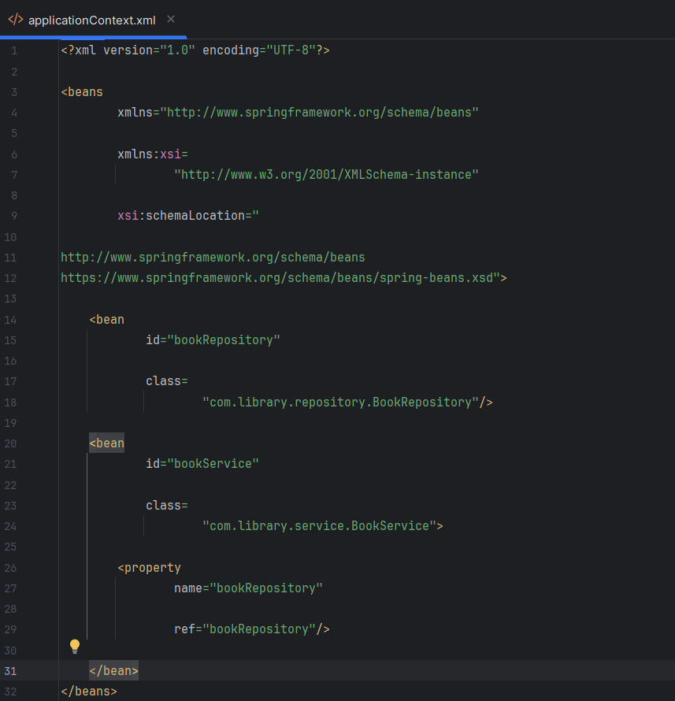

Create a package com.library.service and add a class BookService.
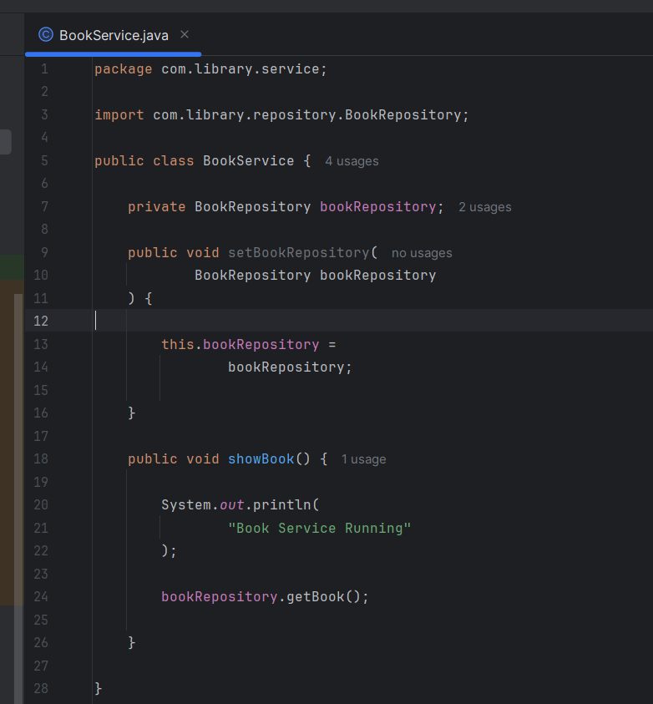

Create a package com.library.repository and add a class BookRepository.
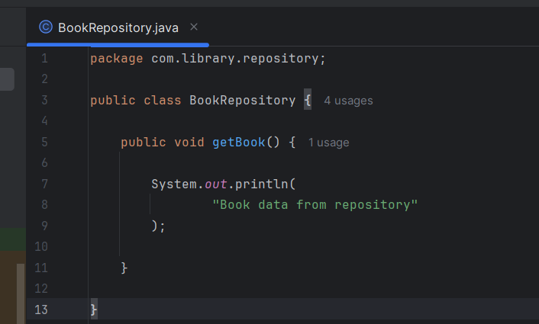

OUTPUT:
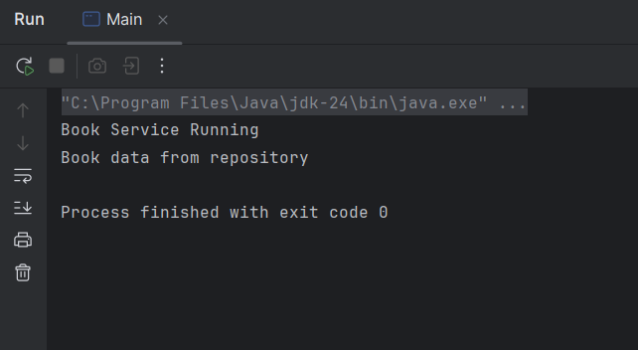

Exercise 2: Implementing Dependency Injection
Update applicationContext.xml to wire BookRepository into BookService.
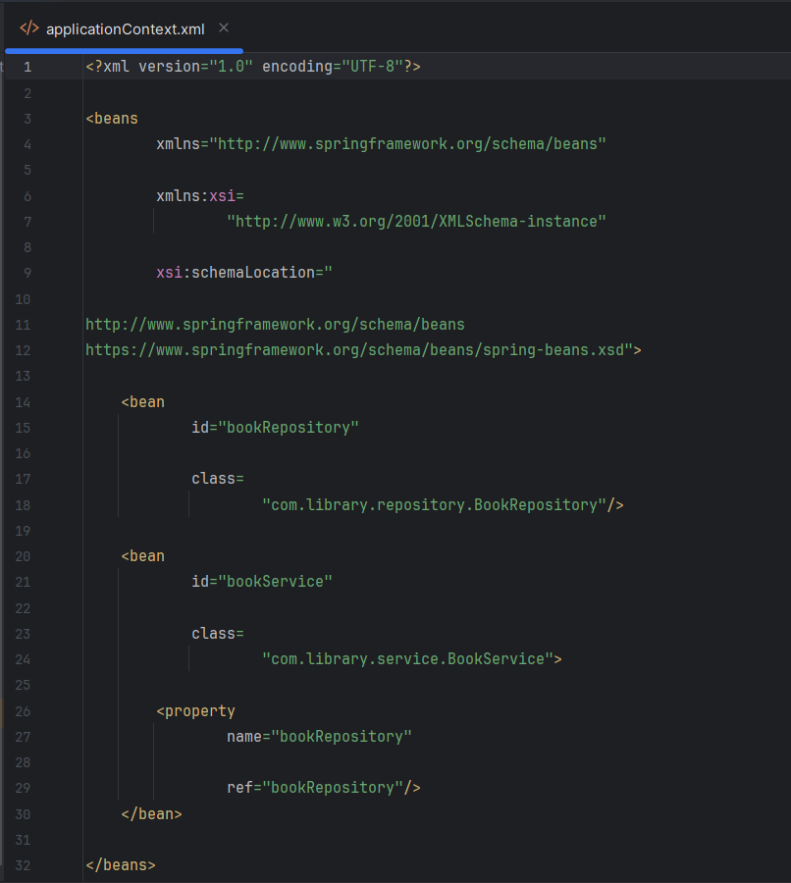

Ensure that BookService class has a setter method for BookRepository.
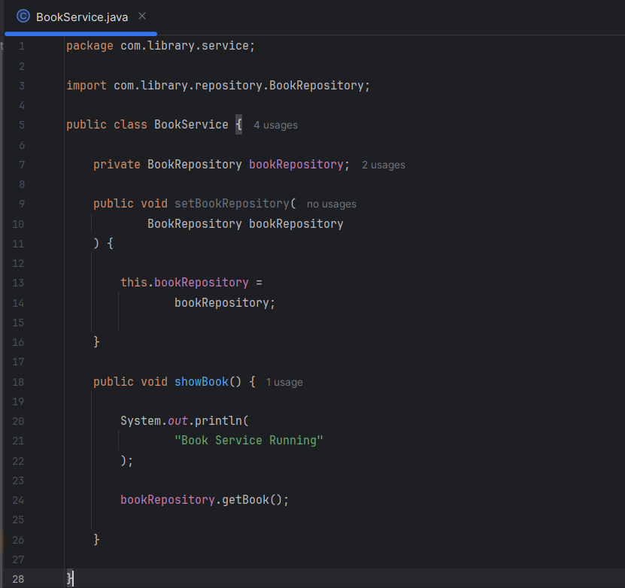

OUTPUT
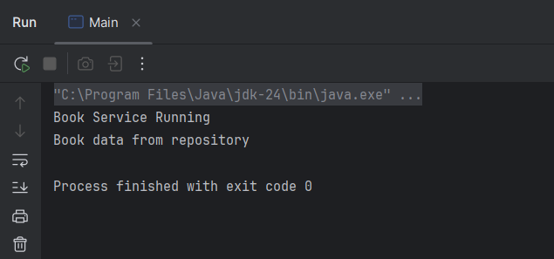
Exercise 3: Implementing Logging with Spring AOP
Update pom.xml to include Spring AOP dependency.
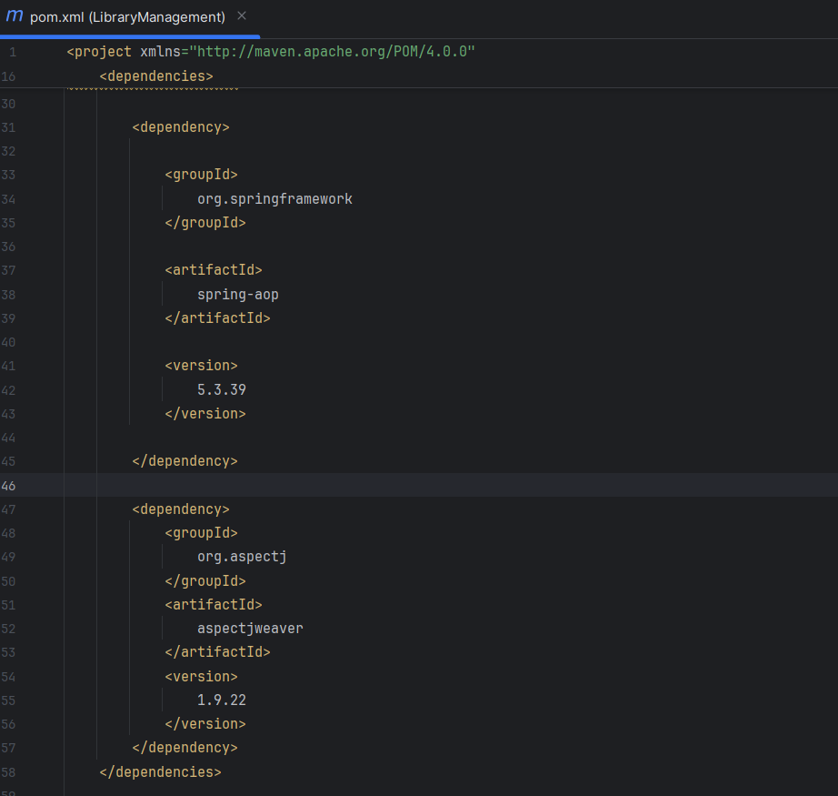

Create a package com.library.aspect and add a class LoggingAspect with a method to log execution times.
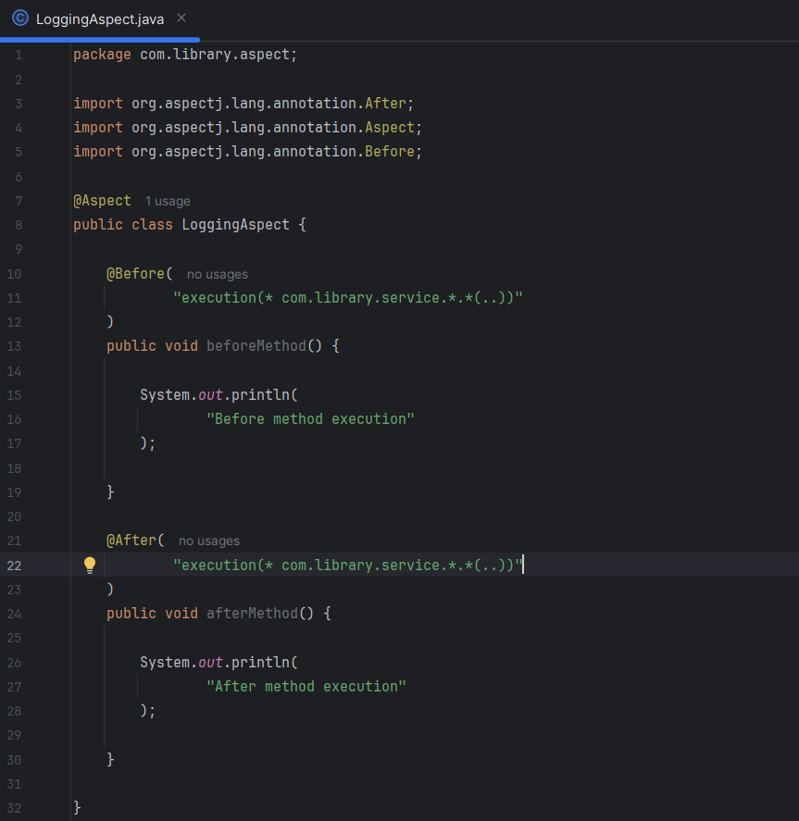

Update applicationContext.xml to enable AspectJ support and register the aspect.
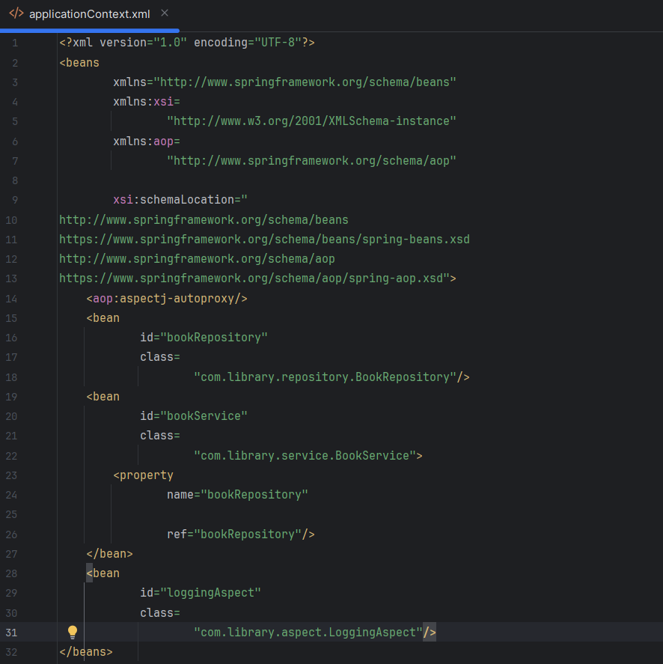

Run the LibraryManagementApplication main class and observe the console for log messages indicating method execution times.
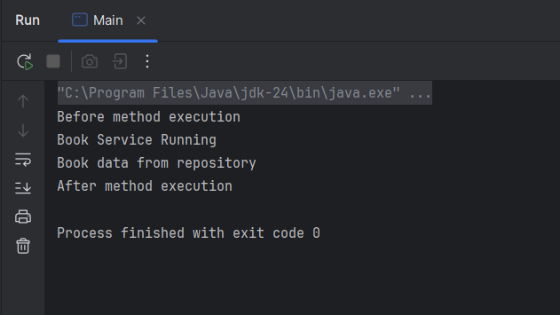

Exercise 4: Creating and Configuring a Maven Project
Add Spring Dependencies in pom.xml and Configure Maven Plugins:
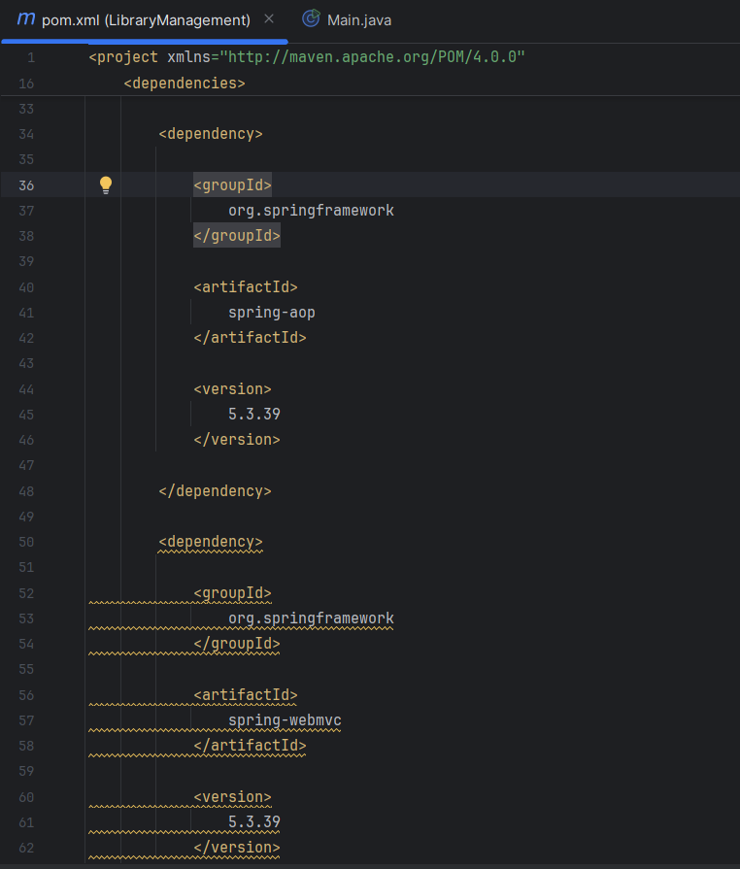
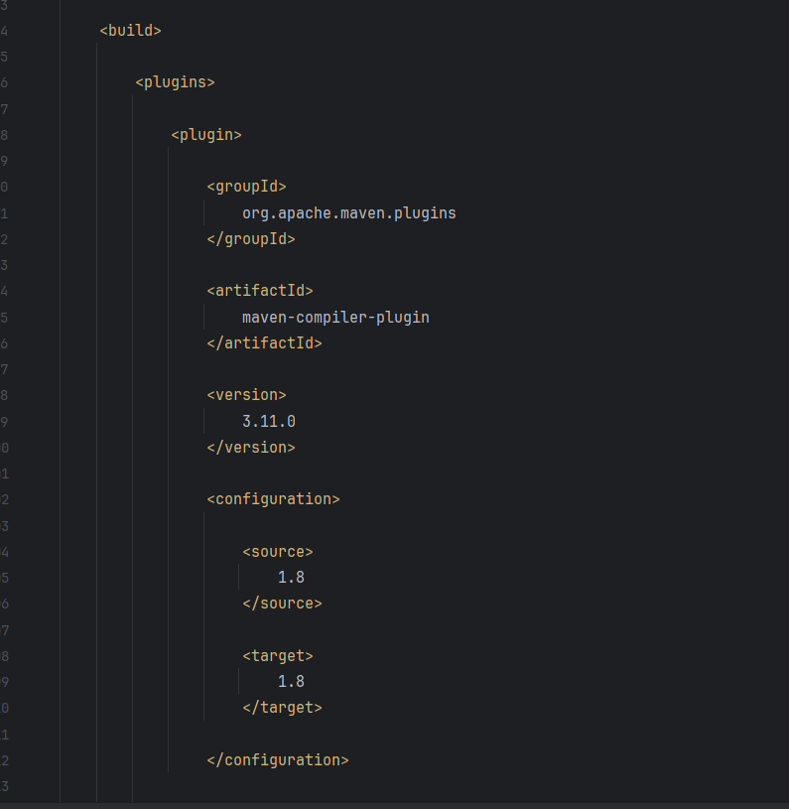

OUTPUT
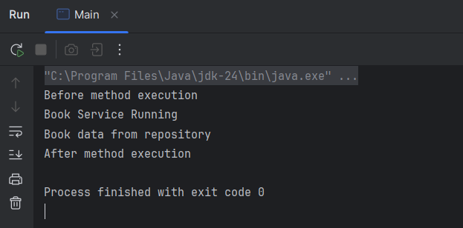

Exercise 5: Configuring the Spring IoC Container
Create an XML configuration file named applicationContext.xml in the src/main/resources directory.
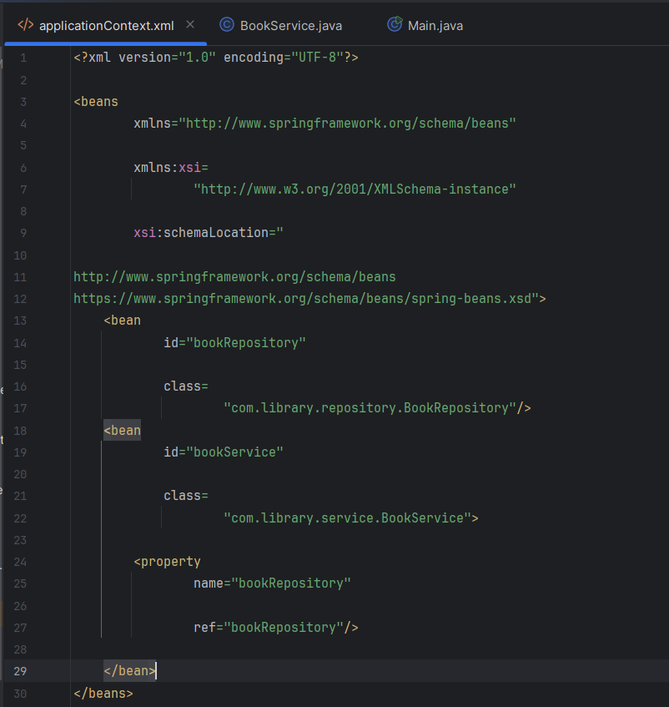

Ensure that the BookService class has a setter method for BookRepository.
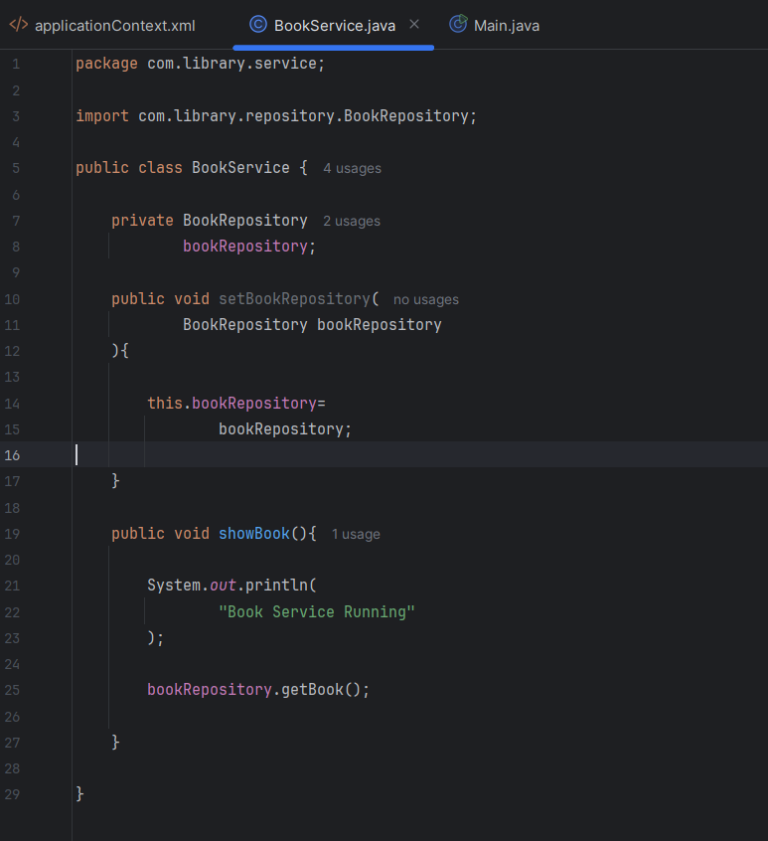

OUTPUT:
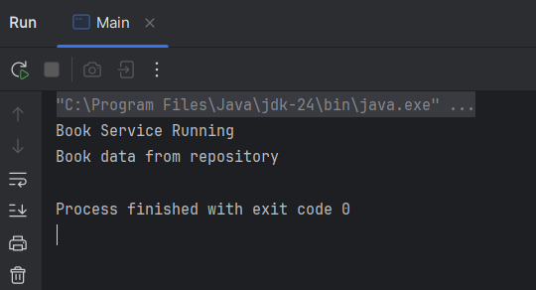

Exercise 6: Configuring Beans with Annotations
Update applicationContext.xml to include component scanning for the com.library package.
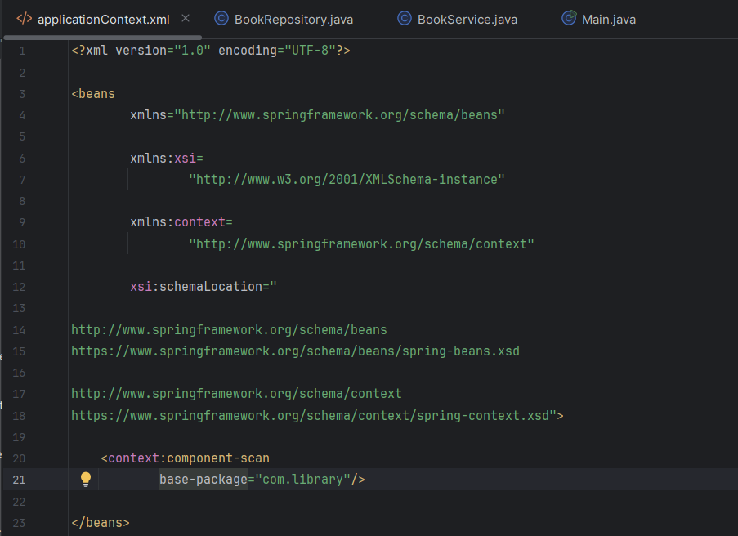

Use @Service annotation for the BookService class.
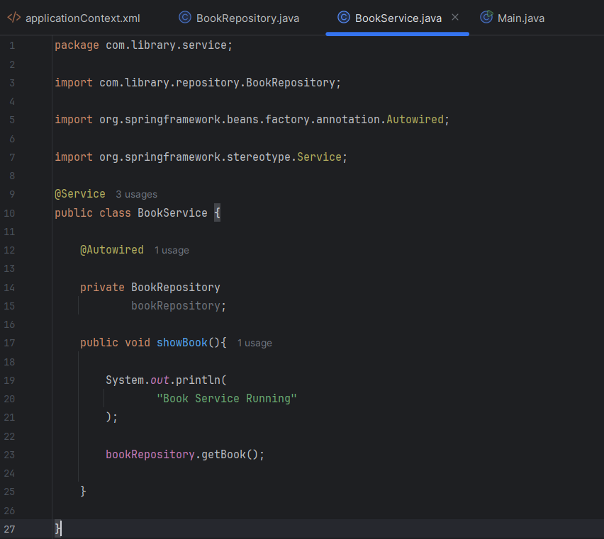

Use @Repository annotation for the BookRepository class.
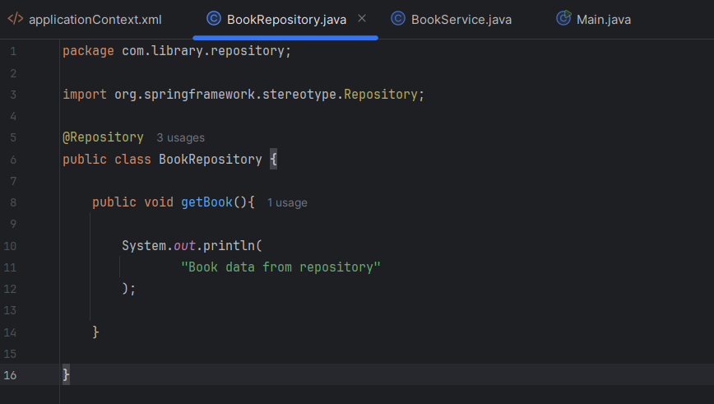
OUTPUT:
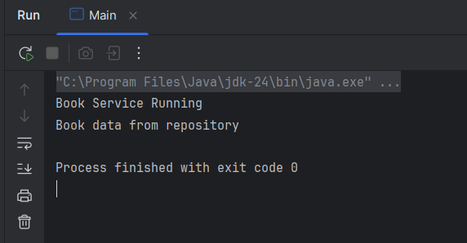

Exercise 7: Implementing Constructor and Setter Injection
Update applicationContext.xml to configure constructor injection for BookService.
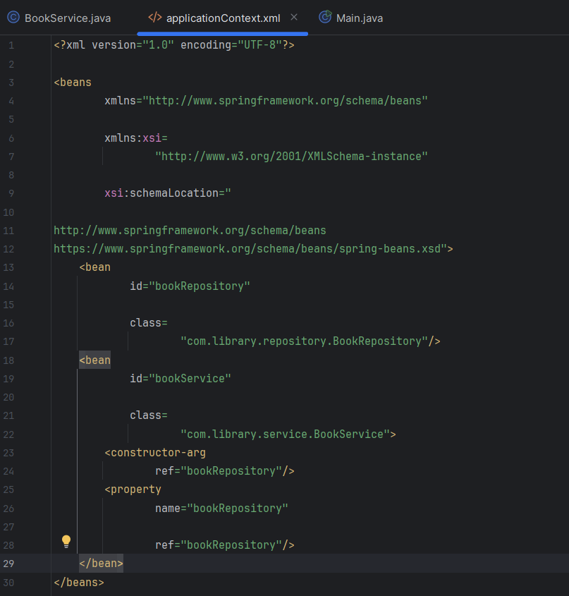

Ensure that the BookService class has a setter method for BookRepository and configure it in applicationContext.xml.
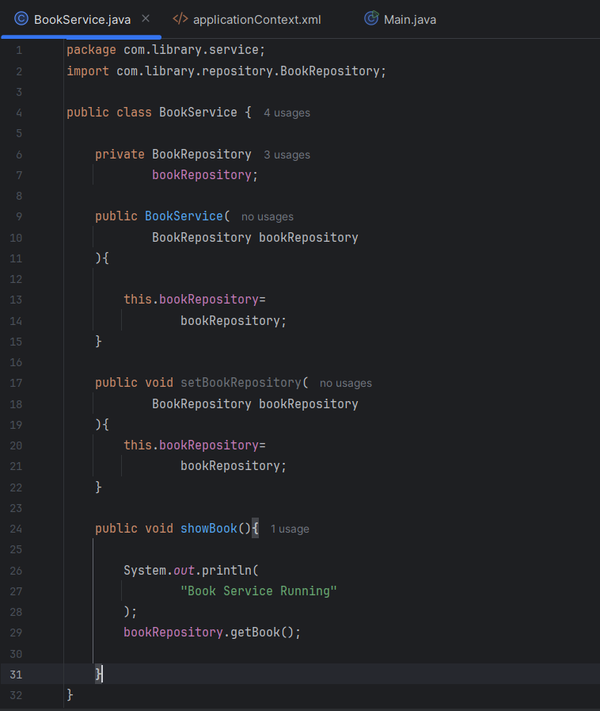

Run the LibraryManagementApplication main class to verify both constructor and setter injection.
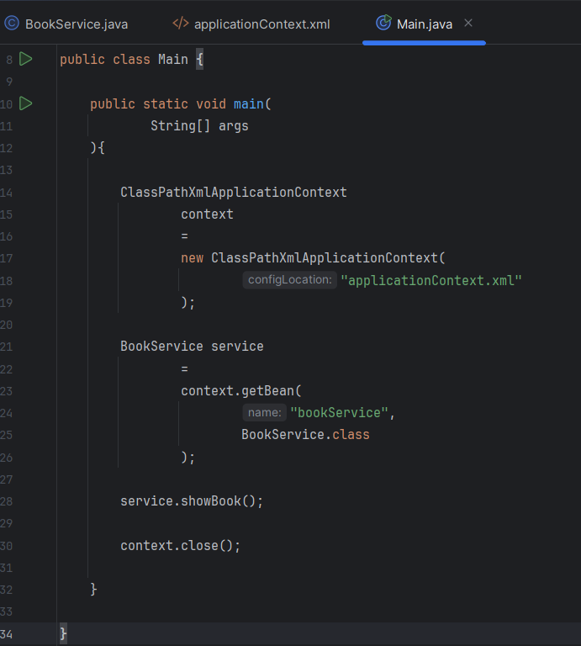

OUTPUT:
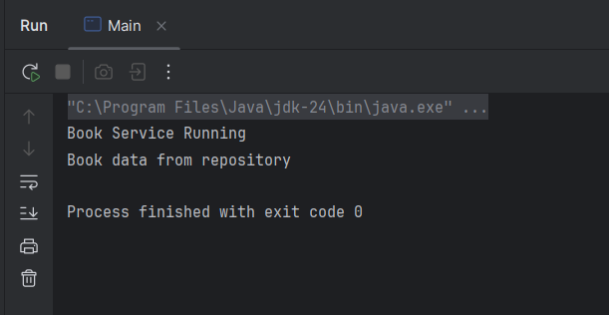

Exercise 8: Implementing Basic AOP with Spring
Define advice methods in LoggingAspect for logging before and after method execution.
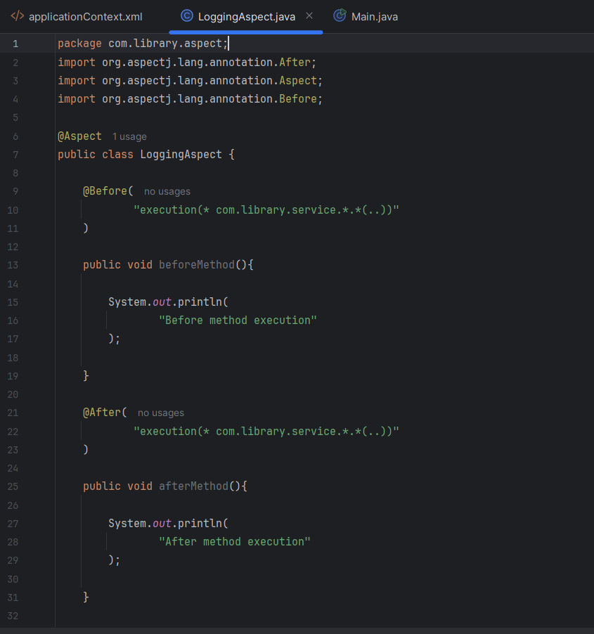

Update applicationContext.xml to register the aspect and enable AspectJ auto-proxying.
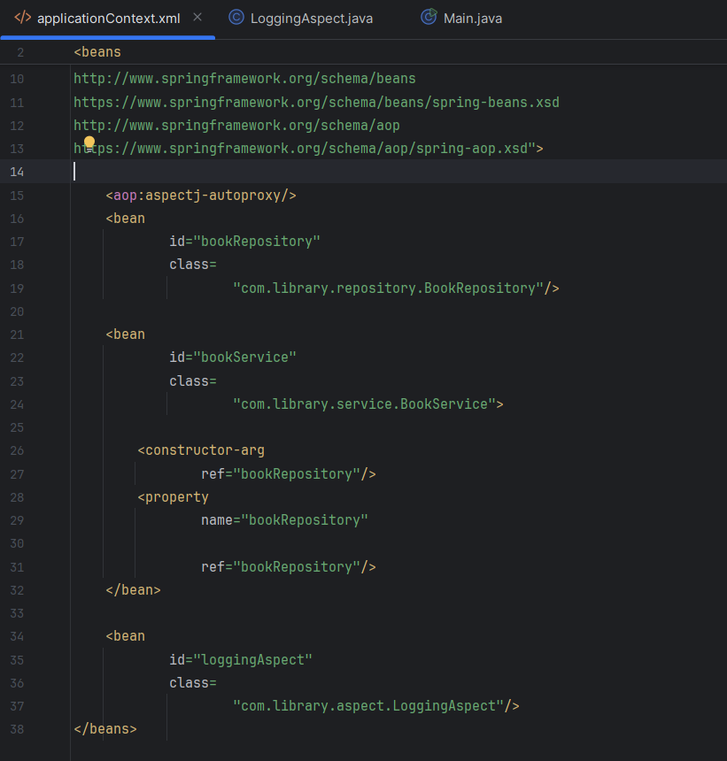

OUTPUT:
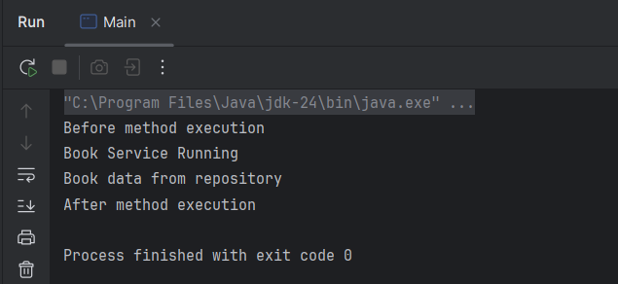

Exercise 9: Creating a Spring Boot Application

Configure database connection properties in application.properties.
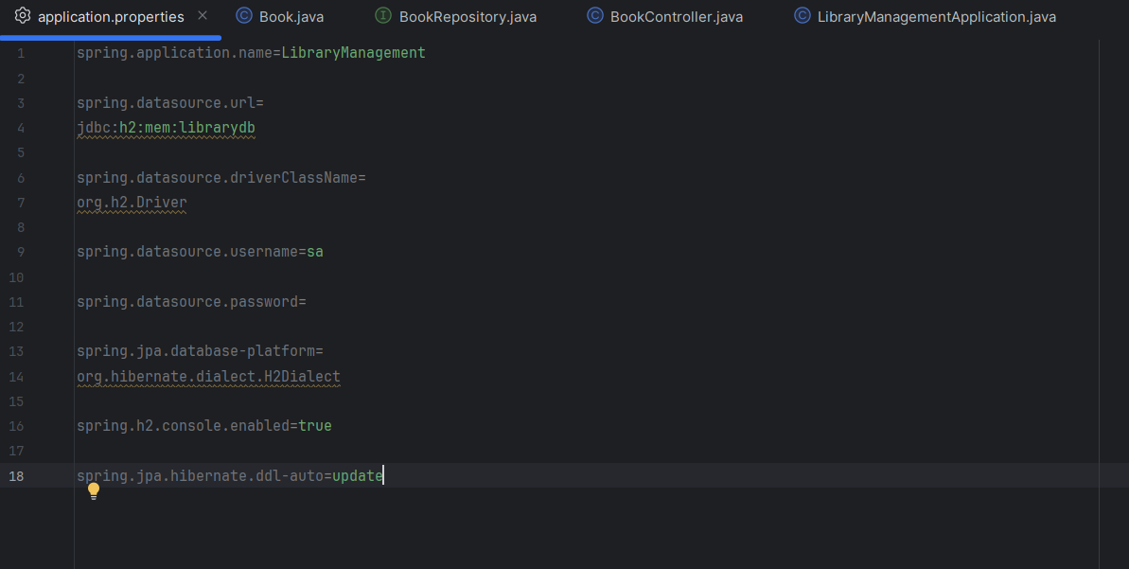

Create Book entity and BookRepository interface.
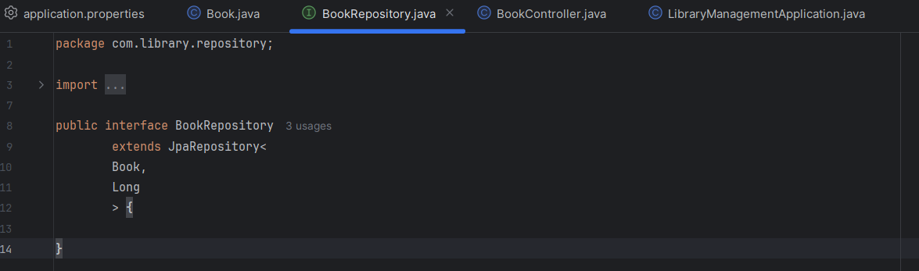
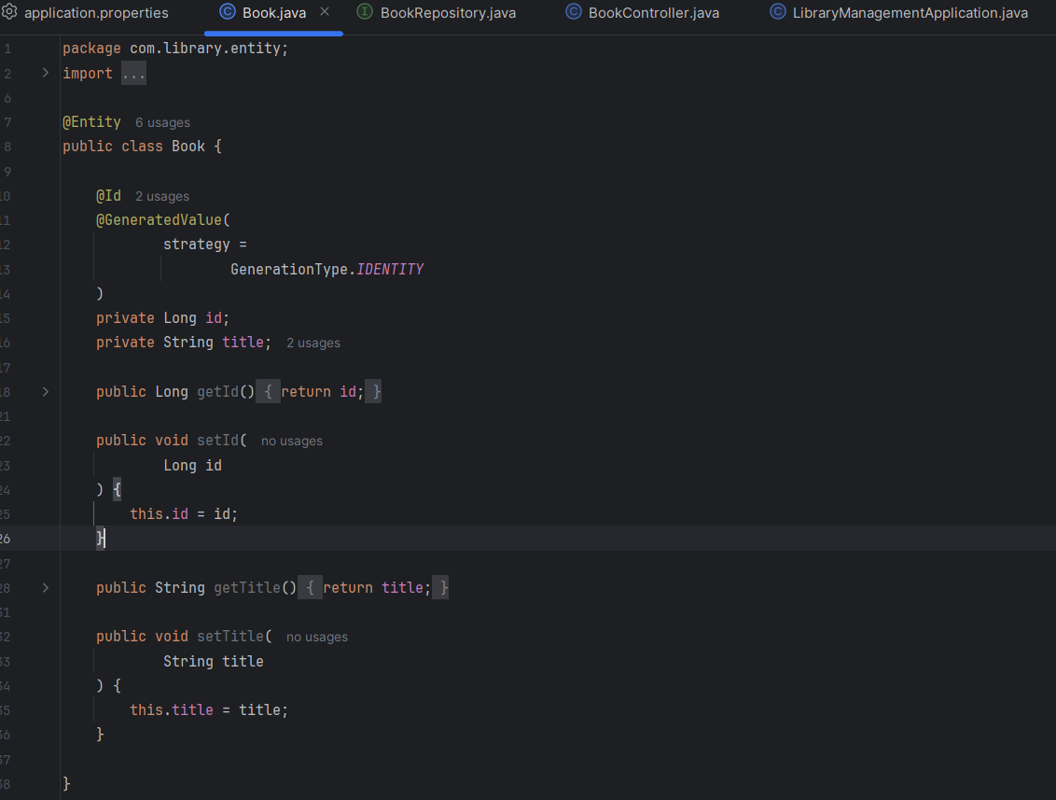

Use Spring Initializr to create a new Spring Boot project named LibraryManagement.
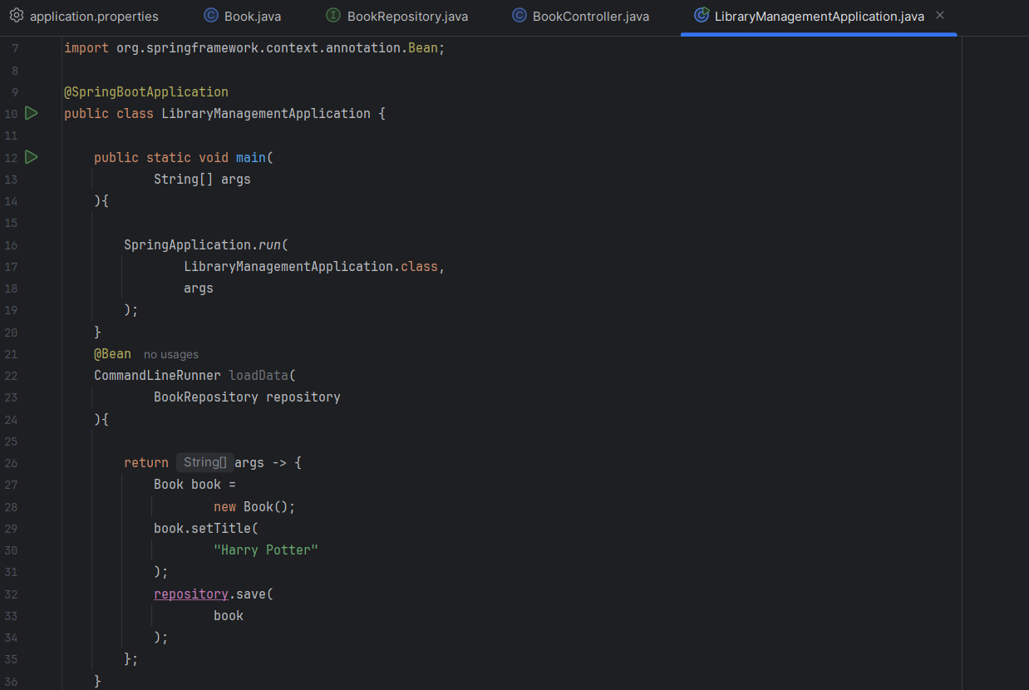

Create a BookController class to handle CRUD operations.
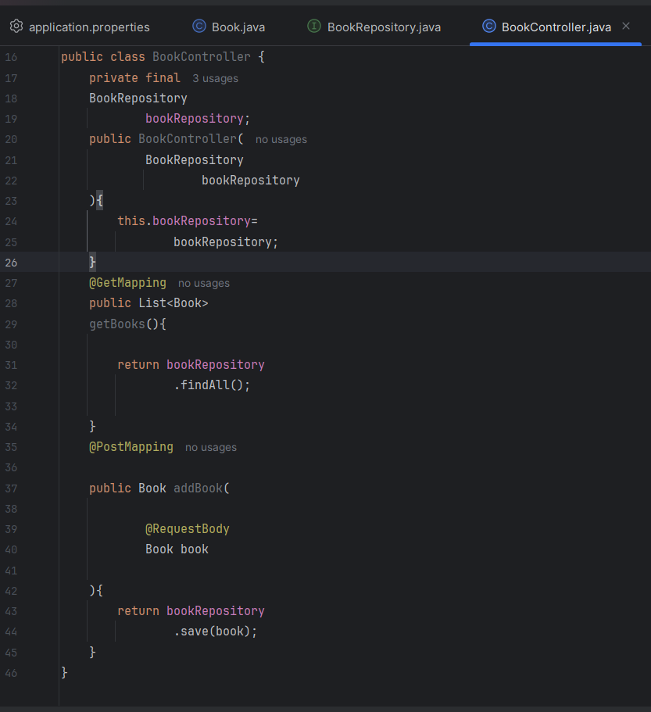

OUTPUT: Localhost:8082/books
